**Install Docker Engine on CentOS**

**Prerequisites**

**OS requirements**

To install Docker Engine, you need a maintained version of CentOS 7, CentOS 8 (stream), or CentOS 9 (stream). Archived versions aren’t supported or tested.

The centos-extras repository must be enabled. This repository is enabled by default, but if you have disabled it, you need to [re-enable it](https://wiki.centos.org/AdditionalResources/Repositories).

Step1

**Uninstall old versions**

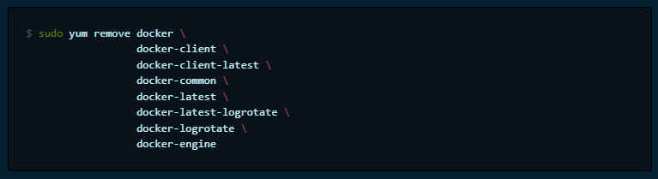

sudo yum remove docker \

docker-client \

docker-client-latest \

docker-common \

docker-latest \

docker-latest-logrotate \

docker-logrotate \

docker-engine

step 2

**Install using the repository**

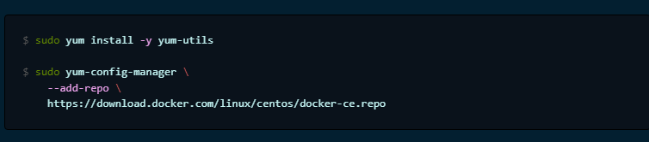

sudo yum install -y yum-utils

sudo yum-config-manager \

--add-repo \

https://download.docker.com/linux/centos/docker-ce.repo

**Install Docker Engine**



sudo yum install docker-ce docker-ce-cli containerd.io docker-compose-plugin

**Start Docker.**



sudo systemctl start docker

**Verify that Docker Engine is installed correctly**



sudo docker run hello-world

**REFFERENCE : https://docs.docker.com/engine/install/centos/**